Exercise 1: Control Structures

**Scenario 1:** The bank wants to apply a discount to loan interest rates for customers above 60 years old.

**Sql:**

SET SERVEROUTPUT ON;

BEGIN

FOR rec IN (SELECT CustomerID, DOB FROM Customers) LOOP

IF MONTHS_BETWEEN(SYSDATE, rec.DOB)/12 > 60 THEN

UPDATE Loans

SET InterestRate = InterestRate - 1

WHERE CustomerID = rec.CustomerID;

DBMS_OUTPUT.PUT_LINE('1% discount applied to CustomerID ' || rec.CustomerID);

END IF;

END LOOP;

END;

/

**OUTPUT:**

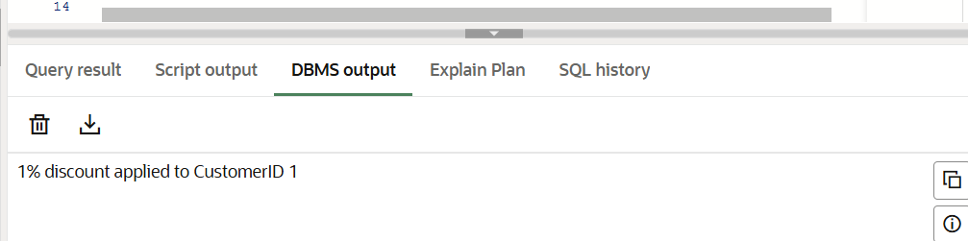

**Scenario 2:** A customer can be promoted to VIP status based on their balance.

**Sql:**

SET SERVEROUTPUT ON;

BEGIN

FOR rec IN (SELECT CustomerID, Balance FROM Customers) LOOP

IF rec.Balance > 10000 THEN

UPDATE Customers

SET IsVIP = 'Y'

WHERE CustomerID = rec.CustomerID;

DBMS_OUTPUT.PUT_LINE('CustomerID ' || rec.CustomerID || ' marked as VIP.');

END IF;

END LOOP;

END;

/

**OUTPUT:**

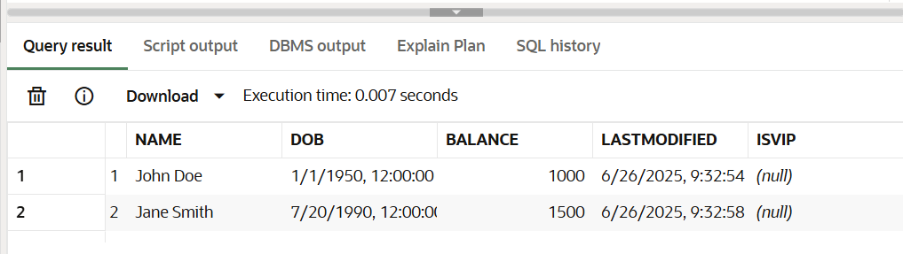

**Scenario 3**: The bank wants to send reminders to customers whose loans are due within the next 30 days.

**Sql:**

SET SERVEROUTPUT ON;

BEGIN

FOR rec IN (

SELECT l.LoanID, l.CustomerID, c.Name, l.EndDate

FROM Loans l

JOIN Customers c ON c.CustomerID = l.CustomerID

WHERE l.EndDate BETWEEN SYSDATE AND SYSDATE + 30

) LOOP

DBMS_OUTPUT.PUT_LINE('Reminder: Loan ID ' || rec.LoanID || ' for customer ' || rec.Name || ' is due on ' || TO_CHAR(rec.EndDate, 'YYYY-MM-DD'));

END LOOP;

END;

**OUTPUT:** 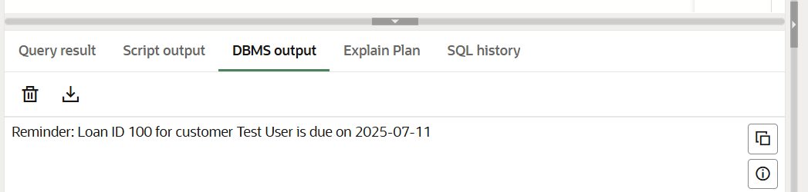

**Exercise 2: Error Handling**

**Scenario 1:** Handle exceptions during fund transfers between accounts.

**SQL:**

BEGIN

-- Get balance of source account

SELECT Balance INTO v_from_balance

FROM Accounts

WHERE AccountID = p_from_acc_id

FOR UPDATE

IF v_from_balance < p_amount THEN

RAISE_APPLICATION_ERROR(-20001, 'Insufficient funds in source account.');

END IF;

-- Deduct from source

UPDATE Accounts

SET Balance = Balance - p_amount,

LastModified = SYSDATE

WHERE AccountID = p_from_acc_id;

-- Add to destination

UPDATE Accounts

SET Balance = Balance + p_amount,

LastModified = SYSDATE

WHERE AccountID = p_to_acc_id;

DBMS_OUTPUT.PUT_LINE('₹' || p_amount || ' transferred from Account ' || p_from_acc_id || ' to ' || p_to_acc_id);

EXCEPTION

WHEN OTHERS THEN

ROLLBACK;

DBMS_OUTPUT.PUT_LINE('Error: ' || SQLERRM);

-- Optional: Log to ErrorLog table

INSERT INTO ErrorLog(ErrorMessage)

VALUES(SQLERRM);

COMMIT; -- commit the log entry

**EXEC SafeTransferFunds(1, 2, 200);**

**OUTPUT:**

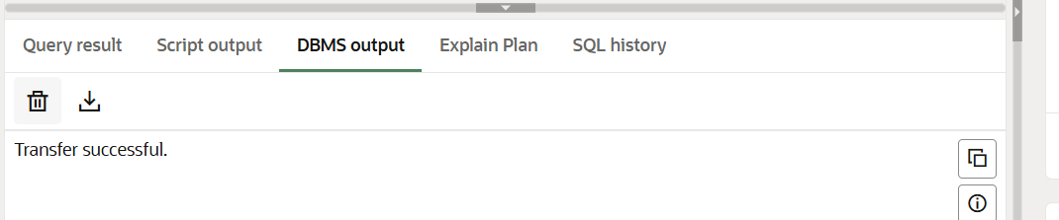

**Scenario 2:** Manage errors when updating employee salaries.

**SQL:**

BEGIN

UPDATE Employees

SET Salary = Salary + (Salary * p_percent / 100)

WHERE EmployeeID = p_emp_id;

IF SQL%ROWCOUNT = 0 THEN

RAISE_APPLICATION_ERROR(-20001, 'Employee ID not found: ' || p_emp_id);

END IF;

DBMS_OUTPUT.PUT_LINE('Salary updated for Employee ID ' || p_emp_id);

EXCEPTION

WHEN OTHERS THEN

v_error_message := SUBSTR(SQLERRM, 1, 400);

DBMS_OUTPUT.PUT_LINE('Error: ' || v_error_message);

INSERT INTO ErrorLog (ErrorMessage) VALUES (v_error_message);

COMMIT;

END;

/ **OUTPUT:**

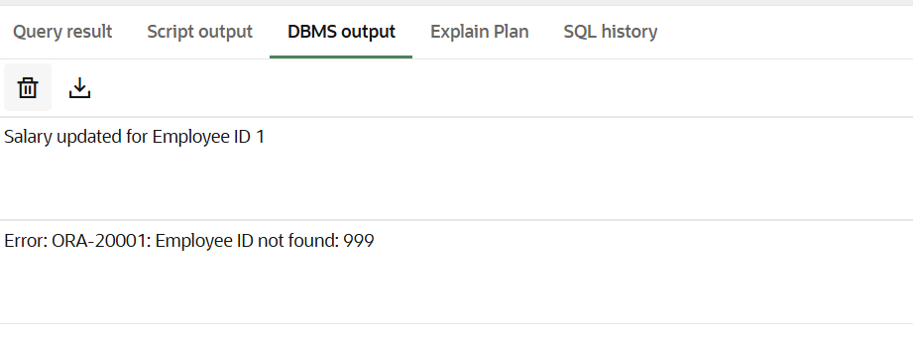

**Scenario 3:** Ensure data integrity when adding a new customer.

**SQL:**

BEGIN

-- Try to insert the customer

INSERT INTO Customers (CustomerID, Name, DOB, Balance, LastModified)

VALUES (p_customer_id, p_name, p_dob, p_balance, SYSDATE);

DBMS_OUTPUT.PUT_LINE('Customer added: ' || p_name);

EXCEPTION

WHEN DUP_VAL_ON_INDEX THEN

v_error_message := 'Duplicate CustomerID: ' || p_customer_id;

DBMS_OUTPUT.PUT_LINE('Error: ' || v_error_message);

INSERT INTO ErrorLog (ErrorMessage) VALUES (v_error_message);

COMMIT;

WHEN OTHERS THEN

v_error_message := SUBSTR(SQLERRM, 1, 400);

DBMS_OUTPUT.PUT_LINE('Unexpected Error: ' || v_error_message);

INSERT INTO ErrorLog (ErrorMessage) VALUES (v_error_message);

COMMIT;

END;

/

OUTPUT:

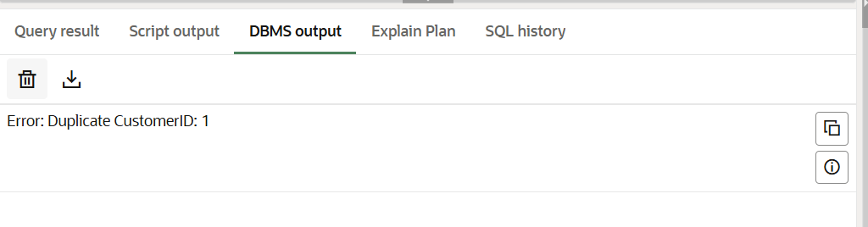

**Exercise 3: Stored Procedures**

**Scenario 1:** The bank needs to process monthly interest for all savings accounts.

* + **Question:** Write a stored procedure **ProcessMonthlyInterest** that calculates and updates the balance of all savings accounts by applying an interest rate of 1% to the current balance.

**SQL:**

CREATE OR REPLACE PROCEDURE ProcessMonthlyInterest IS

BEGIN

UPDATE Accounts

SET Balance = Balance + (Balance * 0.01),

LastModified = SYSDATE

WHERE AccountType = 'Savings';

END;

/

BEGIN

ProcessMonthlyInterest;

END;

/

**OUTPUT:**

**Scenario 2:** The bank wants to implement a bonus scheme for employees based on their performance.

* + **Question:** Write a stored procedure **UpdateEmployeeBonus** that updates the salary of employees in a given department by adding a bonus percentage passed as a parameter.

**SQL:**

CREATE OR REPLACE PROCEDURE UpdateEmployeeBonus(

p_department IN VARCHAR2,

p_bonus_percent IN NUMBER

) IS

BEGIN

UPDATE Employees

SET Salary = Salary + (Salary * (p_bonus_percent / 100))

WHERE Department = p_department;

END;

/

BEGIN

UpdateEmployeeBonus('HR', 10); -- Gives 10% bonus to HR department

END;

/

**OUTPUT:**

**Scenario 3:** Customers should be able to transfer funds between their accounts.

* + **Question:** Write a stored procedure **TransferFunds** that transfers a specified amount from one account to another, checking that the source account has sufficient balance before making the transfer.

**SQL:**

CREATE OR REPLACE PROCEDURE TransferFunds(

p_source_account IN NUMBER,

p_target_account IN NUMBER,

p_amount IN NUMBER

) IS

source_balance NUMBER;

BEGIN

-- Check source balance

SELECT Balance INTO source_balance

FROM Accounts

WHERE AccountID = p_source_account;

IF source_balance < p_amount THEN

RAISE_APPLICATION_ERROR(-20001, 'Insufficient balance in source account.');

END IF;

-- Deduct from source

UPDATE Accounts

SET Balance = Balance - p_amount,

LastModified = SYSDATE

WHERE AccountID = p_source_account;

-- Add to target

UPDATE Accounts

SET Balance = Balance + p_amount,

LastModified = SYSDATE

WHERE AccountID = p_target_account;

-- Log transactions (optional)

INSERT INTO Transactions (TransactionID, AccountID, TransactionDate, Amount, TransactionType)

VALUES (Transactions_SEQ.NEXTVAL, p_source_account, SYSDATE, p_amount, 'Transfer Out');

INSERT INTO Transactions (TransactionID, AccountID, TransactionDate, Amount, TransactionType)

VALUES (Transactions_SEQ.NEXTVAL, p_target_account, SYSDATE, p_amount, 'Transfer In');

END;

/

BEGIN

TransferFunds(1, 2, 200); -- Transfer 200 from Account 1 to 2

END;

/

**OUTPUT:**

**Exercise 4: Functions**

**Scenario 1:** Calculate the age of customers for eligibility checks.

* + **Question:** Write a function CalculateAge that takes a customer's date of birth as input and returns their age in years.

**SQL:**

CREATE OR REPLACE FUNCTION CalculateAge(dob DATE)

RETURN NUMBER IS

age NUMBER;

BEGIN

age := FLOOR(MONTHS_BETWEEN(SYSDATE, dob) / 12);

RETURN age;

END;

/

BEGIN

DBMS_OUTPUT.PUT_LINE('Age: ' || CalculateAge(TO_DATE('1990-07-20', 'YYYY-MM-DD')));

END;

/

**OUTPUT:**

**Scenario 2:** The bank needs to compute the monthly installment for a loan.

* + **Question:** Write a function CalculateMonthlyInstallment that takes the loan amount, interest rate, and loan duration in years as input and returns the monthly installment amount.

**SQL:**

CREATE OR REPLACE FUNCTION CalculateMonthlyInstallment(

loan_amount NUMBER,

annual_interest_rate NUMBER,

loan_duration_years NUMBER

)

RETURN NUMBER IS

monthly_rate NUMBER;

total_months NUMBER;

emi NUMBER;

BEGIN

monthly_rate := annual_interest_rate / 12 / 100;

total_months := loan_duration_years * 12;

IF monthly_rate = 0 THEN

emi := loan_amount / total_months;

ELSE

emi := loan_amount * monthly_rate * POWER(1 + monthly_rate, total_months) /

(POWER(1 + monthly_rate, total_months) - 1);

END IF;

RETURN ROUND(emi, 2);

END;

/

BEGIN

DBMS_OUTPUT.PUT_LINE('Monthly EMI: ' || CalculateMonthlyInstallment(50000, 7.5, 5));

END;

/

**OUTPUT:**

**Scenario 3:** Check if a customer has sufficient balance before making a transaction.

* + **Question:** Write a function HasSufficientBalance that takes an account ID and an amount as input and returns a boolean indicating whether the account has at least the specified amount.

**SQL:**

CREATE OR REPLACE FUNCTION HasSufficientBalance(

p_account_id NUMBER,

p_amount NUMBER

)

RETURN NUMBER IS

available_balance NUMBER;

BEGIN

SELECT Balance INTO available_balance

FROM Accounts

WHERE AccountID = p_account_id;

IF available_balance >= p_amount THEN

RETURN 1;

ELSE

RETURN 0;

END IF;

EXCEPTION

WHEN NO_DATA_FOUND THEN

RETURN 0;

END;

/

DECLARE

result NUMBER;

BEGIN

result := HasSufficientBalance(1, 500);

IF result = 1 THEN

DBMS_OUTPUT.PUT_LINE('Sufficient balance.');

ELSE

DBMS_OUTPUT.PUT_LINE('Insufficient balance.');

END IF;

END;

/

**OUTPUT:**

**Exercise 5: Triggers**

**Scenario 1:** Automatically update the last modified date when a customer's record is updated.

**o Question:** Write a trigger UpdateCustomerLastModified that updates the LastModified column of the Customers table to the current date whenever a customer's record is updated.

**SQL:**

CREATE OR REPLACE TRIGGER UpdateCustomerLastModified

BEFORE UPDATE ON Customers

FOR EACH ROW

BEGIN

:NEW.LastModified := SYSDATE;

END;

/

UPDATE Customers SET Name = 'John A. Doe' WHERE CustomerID = 1;

SELECT Name, LastModified FROM Customers WHERE CustomerID = 1;

**OUTPUT:**

**Scenario 2:** Maintain an audit log for all transactions.

o **Question:** Write a trigger LogTransaction that inserts a record into an AuditLog table whenever a transaction is inserted into the Transactions table.

**SQL:**

CREATE TABLE AuditLog (

AuditID NUMBER GENERATED BY DEFAULT ON NULL AS IDENTITY PRIMARY KEY,

TransactionID NUMBER,

AccountID NUMBER,

Amount NUMBER,

TransactionType VARCHAR2(10),

LoggedAt DATE

);

CREATE OR REPLACE TRIGGER LogTransaction

AFTER INSERT ON Transactions

FOR EACH ROW

BEGIN

INSERT INTO AuditLog (TransactionID, AccountID, Amount, TransactionType, LoggedAt)

VALUES (:NEW.TransactionID, :NEW.AccountID, :NEW.Amount, :NEW.TransactionType, SYSDATE);

END;

/

INSERT INTO Transactions (TransactionID, AccountID, TransactionDate, Amount, TransactionType)

VALUES (3, 1, SYSDATE, 100, 'Deposit');

SELECT * FROM AuditLog;

**OUTPUT:**

**Scenario 3:** Enforce business rules on deposits and withdrawals.

**o Question:** Write a trigger CheckTransactionRules that ensures withdrawals do not exceed the balance and deposits are positive before inserting a record into the Transactions table.

**SQL:**

CREATE OR REPLACE TRIGGER CheckTransactionRules

BEFORE INSERT ON Transactions

FOR EACH ROW

DECLARE

account_balance NUMBER;

BEGIN

-- Get current balance

SELECT Balance INTO account_balance

FROM Accounts

WHERE AccountID = :NEW.AccountID;

-- Rule 1: Deposit must be positive

IF :NEW.TransactionType = 'Deposit' AND :NEW.Amount <= 0 THEN

RAISE_APPLICATION_ERROR(-20001, 'Deposit amount must be positive.');

END IF;

-- Rule 2: Withdrawal must not exceed balance

IF :NEW.TransactionType = 'Withdrawal' AND :NEW.Amount > account_balance THEN

RAISE_APPLICATION_ERROR(-20002, 'Insufficient balance for withdrawal.');

END IF;

END;

/

INSERT INTO Transactions (TransactionID, AccountID, TransactionDate, Amount, TransactionType)

VALUES (4, 1, SYSDATE, 50, 'Withdrawal');

-- This will throw an error

INSERT INTO Transactions (TransactionID, AccountID, TransactionDate, Amount, TransactionType)

VALUES (5, 1, SYSDATE, -200, 'Deposit');

**OUTPUT:**

**Exercise 6: Cursors**

**Scenario 1:** Generate monthly statements for all customers.

**SQL:**

SET SERVEROUTPUT ON;

DECLARE

    CURSOR txn_cursor IS

        SELECT c.Name, t.AccountID, t.TransactionDate, t.Amount, t.TransactionType

        FROM Transactions t

        JOIN Accounts a ON a.AccountID = t.AccountID

        JOIN Customers c ON c.CustomerID = a.CustomerID

        WHERE TO_CHAR(t.TransactionDate, 'MMYYYY') = TO_CHAR(SYSDATE, 'MMYYYY');

    v_name Customers.Name%TYPE;

    v_acct_id Accounts.AccountID%TYPE;

    v_date DATE;

    v_amt NUMBER;

    v_type VARCHAR2(10);

BEGIN

    DBMS_OUTPUT.PUT_LINE('--- Monthly Statements ---');

    OPEN txn_cursor;

    LOOP

        FETCH txn_cursor INTO v_name, v_acct_id, v_date, v_amt, v_type;

        EXIT WHEN txn_cursor%NOTFOUND;

        DBMS_OUTPUT.PUT_LINE('Customer: ' || v_name || ', Account: ' || v_acct_id || ', Date: ' || TO_CHAR(v_date, 'YYYY-MM-DD') || ', Amount: ' || v_amt || ', Type: ' || v_type);

    END LOOP;

    CLOSE txn_cursor;

END;

/

**OUTPUT:**

**Scenario 2:** Apply annual fee to all accounts

**SQL:**

SET SERVEROUTPUT ON;

DECLARE

    CURSOR acc_cursor IS

        SELECT AccountID, Balance FROM Accounts;

    v_acc_id Accounts.AccountID%TYPE;

    v_balance NUMBER;

    v_fee CONSTANT NUMBER := 100;

BEGIN

    OPEN acc_cursor;

    LOOP

        FETCH acc_cursor INTO v_acc_id, v_balance;

        EXIT WHEN acc_cursor%NOTFOUND;

        UPDATE Accounts

        SET Balance = Balance - v_fee,

            LastModified = SYSDATE

        WHERE AccountID = v_acc_id;

        DBMS_OUTPUT.PUT_LINE('Annual fee of ₹' || v_fee || ' deducted from Account ' || v_acc_id);

    END LOOP;

    CLOSE acc_cursor;

END;

/

**OUTPUT:**

**Scenario 3:** Update the interest rate for all loans based on a new policy.

**SQL:**

SET SERVEROUTPUT ON;

DECLARE

    CURSOR loan_cursor IS

        SELECT LoanID, InterestRate FROM Loans;

    v_loan_id Loans.LoanID%TYPE;

    v_rate Loans.InterestRate%TYPE;

BEGIN

    OPEN loan_cursor;

    LOOP

        FETCH loan_cursor INTO v_loan_id, v_rate;

        EXIT WHEN loan_cursor%NOTFOUND;

        IF v_rate < 6 THEN

            UPDATE Loans SET InterestRate = InterestRate + 0.5 WHERE LoanID = v_loan_id;

            DBMS_OUTPUT.PUT_LINE('Loan ' || v_loan_id || ': Interest increased to ' || (v_rate + 0.5));

        ELSE

            UPDATE Loans SET InterestRate = InterestRate - 0.25 WHERE LoanID = v_loan_id;

            DBMS_OUTPUT.PUT_LINE('Loan ' || v_loan_id || ': Interest reduced to ' || (v_rate - 0.25));

        END IF;

    END LOOP;

    CLOSE loan_cursor;

END;

/

**OUTPUT:**

**Exercise 7: Packages**

**Scenario 1:** Group all customer-related procedures and functions into a package.

**SQL:**

SET SERVEROUTPUT ON;

DECLARE

    CURSOR txn_cursor IS

        SELECT c.Name, t.AccountID, t.TransactionDate, t.Amount, t.TransactionType

        FROM Transactions t

        JOIN Accounts a ON a.AccountID = t.AccountID

        JOIN Customers c ON c.CustomerID = a.CustomerID

        WHERE TO_CHAR(t.TransactionDate, 'MMYYYY') = TO_CHAR(SYSDATE, 'MMYYYY');

    v_name Customers.Name%TYPE;

    v_acct_id Accounts.AccountID%TYPE;

    v_date DATE;

    v_amt NUMBER;

    v_type VARCHAR2(10);

BEGIN

    DBMS_OUTPUT.PUT_LINE('--- Monthly Statements ---');

    OPEN txn_cursor;

    LOOP

        FETCH txn_cursor INTO v_name, v_acct_id, v_date, v_amt, v_type;

        EXIT WHEN txn_cursor%NOTFOUND;

        DBMS_OUTPUT.PUT_LINE('Customer: ' || v_name || ', Account: ' || v_acct_id || ', Date: ' || TO_CHAR(v_date, 'YYYY-MM-DD') || ', Amount: ' || v_amt || ', Type: ' || v_type);

    END LOOP;

    CLOSE txn_cursor;

END;

/

**OUTPUT:**

**Scenario 2:** Create a package to manage employee data

**SQL:**

CREATE OR REPLACE PACKAGE BODY EmployeeManagement AS

    PROCEDURE HireEmployee(p_id NUMBER, p_name VARCHAR2, p_position VARCHAR2, p_salary NUMBER, p_dept VARCHAR2) IS

    BEGIN

        INSERT INTO Employees (EmployeeID, Name, Position, Salary, Department, HireDate)

        VALUES (p_id, p_name, p_position, p_salary, p_dept, SYSDATE);

        DBMS_OUTPUT.PUT_LINE('Employee hired: ' || p_name);

    END;

    PROCEDURE UpdateEmployee(p_id NUMBER, p_position VARCHAR2, p_salary NUMBER) IS

    BEGIN

        UPDATE Employees

        SET Position = p_position, Salary = p_salary

        WHERE EmployeeID = p_id;

        DBMS_OUTPUT.PUT_LINE('Employee updated: ' || p_id);

    END;

    FUNCTION GetAnnualSalary(p_id NUMBER) RETURN NUMBER IS

        v_salary NUMBER;

    BEGIN

        SELECT Salary INTO v_salary FROM Employees WHERE EmployeeID = p_id;

        RETURN v_salary * 12;

    EXCEPTION

        WHEN NO_DATA_FOUND THEN

            RETURN -1;

    END;

END EmployeeManagement;

/

**OUTPUT:**

**Scenario 3:** Group all account-related operations into a package.

**SQL:**

CREATE OR REPLACE PACKAGE BODY AccountOperations AS

    PROCEDURE OpenAccount(p_acc_id NUMBER, p_cust_id NUMBER, p_type VARCHAR2, p_balance NUMBER) IS

    BEGIN

        INSERT INTO Accounts (AccountID, CustomerID, AccountType, Balance, LastModified)

        VALUES (p_acc_id, p_cust_id, p_type, p_balance, SYSDATE);

        DBMS_OUTPUT.PUT_LINE('Account opened: ' || p_acc_id);

    END;

    PROCEDURE CloseAccount(p_acc_id NUMBER) IS

    BEGIN

        DELETE FROM Accounts WHERE AccountID = p_acc_id;

        DBMS_OUTPUT.PUT_LINE('Account closed: ' || p_acc_id);

    END;

    FUNCTION GetTotalBalance(p_cust_id NUMBER) RETURN NUMBER IS

        v_total NUMBER;

    BEGIN

        SELECT NVL(SUM(Balance), 0) INTO v_total FROM Accounts WHERE CustomerID = p_cust_id;

        RETURN v_total;

    END;

END AccountOperations;

/

**OUTPUT:**

